# Liability Form

I, ___Lin Gao____, gives permission to the reproducibility committee and reviewers to review the code and advertise the review publicly after the stamp is approved.

___________________

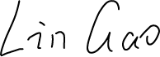Signature

___________________

Date

19-Feb-2020